4233648 - Division - Hide division numbers on reports
Division enhancement: Option to hide Division numbers on reports (Epic 4233648)1. Customer Problemexpect their native account numbers; firm-added division prefixes cause confusion on client-facing reports and add-in outputs.
2. Customer Researchcites Anchin workflow with DD* masks and client expectations.
3. Our SolutionDisplay option to show/hide division prefixes on reports and in Office add-in outputs, without changing stored account numbers.
Dependencies: reporting renderer, add-in formatting, mask service.
4. Product MetricsRework due to formatting complaints: -90%.
- Report setting reuse rate: >80%.
Appendix: Child Features4203581 Option to hide Division numbers on reports
Appendix: Quick prototypePDF examples to illustrate per-division presentation without prefixes.
Appendix: LinksHYPERLINK "https://dev.azure.com/tr-tax/TaxProf/_workitems/edit/4233648"Open Epic 4233648

Appendix: Quick prototype
Figure: PDF page 67
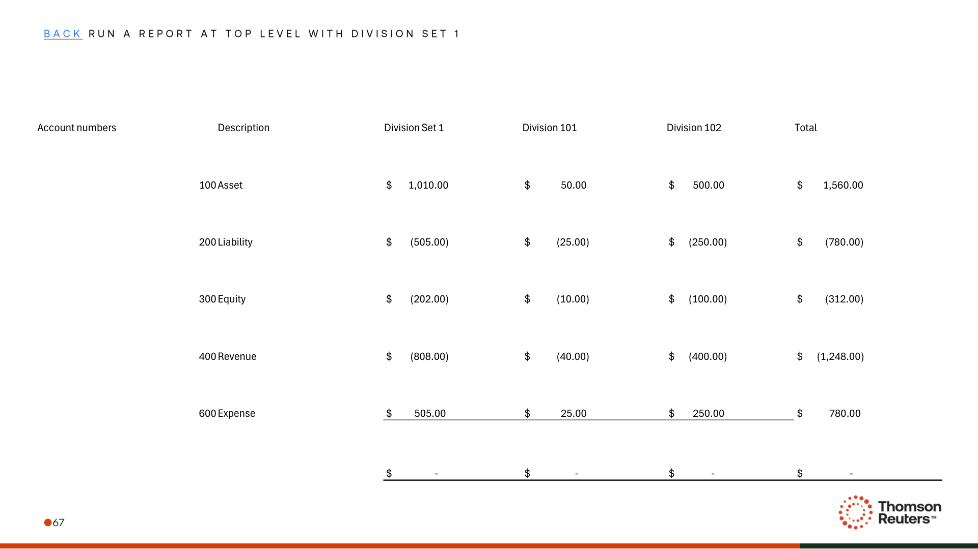
Figure: PDF page 71
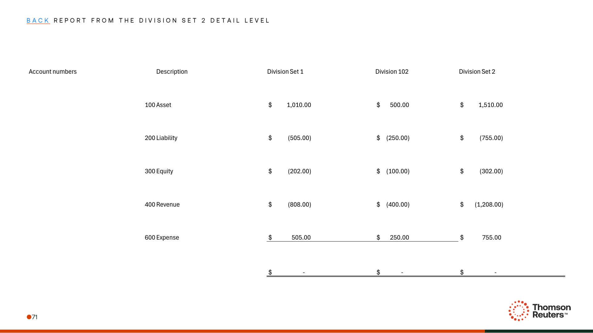
Figure: PDF page 72
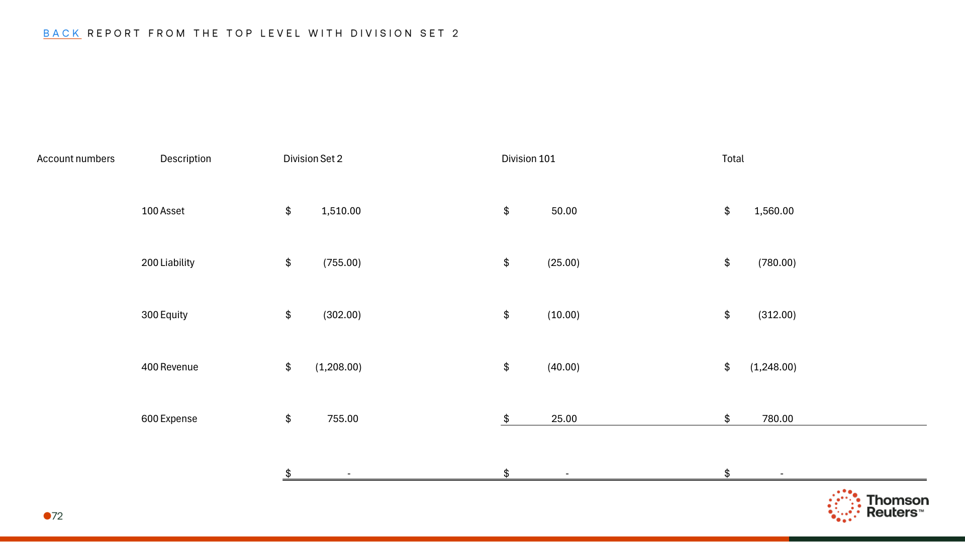

Appendix: Links
ADO Epic Link: https://dev.azure.com/tr-tax/TaxProf/_workitems/edit/4233648

